Risk Analysis

B Kendrick, A Syed

Contents

Introduction 3

Risk Identification 3

Risk Prioritisation and Classification 3

Failing to extensively learn new platform 4

Only 2 members in the group 4

Little feedback on qualitative studies 5

Conflicting Workloads 5

Illness, family matters and extenuating circumstances 5

Risk Control and Resolution 5

Failing to extensively learn new platform 5

Only 2 members in the group 6

Little feedback on qualitative studies 6

Conflicting Workloads 6

Illness, family matters and extenuating circumstances 6

Project Certainty 7

Conclusion 8

# Introduction

This documents purpose is to analyse any risks involved in this project and to propose several risk planning and prevention strategies.

First the risks will be identified and discussed; this will then be followed with a risk prioritisation and classification.

The risk control and resolution section will discuss and propose plans and strategies on how to respond to each identified risk.

The last section will feature a project certainty analysis which takes all the risk into account and propose a development strategy.

In any project there are a number of risks that have to be considered. It is important that we identify risks as early as possible and factor their impact on projects feasibility. A project with a high risk factor may be deemed unsuitable or unworthy of time and effort taken in its execution.

# Risk Identification

In this section the risks of this group project will be identified and briefly discussed.

In our project there are key risks that have to be considered:

* **Failing to extensively learn new platform –** This risk of having to create a software product for a previously unused and unknown platform. That platform that is unknown is the Eclipse Plugin Development Environment (**PDE**).
* **Only 2 members in the group -** This risk has to do with the small number of team members for the group project, this is a result of the limited number of students enrolled at MEng level this year. This means that the amount of man hours is significantly decreased when compared to other projects with larger teams. Therefore an appropriate strategy will need to be taken to ensure meeting milestones and to ensure fair workloads between team members.
* **Little feedback on qualitative studies –** The lack of response from surveys and questionnaires could lead to a lack of qualitative information which can be used measure the results of the project.
* **Conflicting Workloads –** For the members of the team there may be issues related to the workload given from other sources, such as other modules demanding more time than expected. Here the underestimation of the other modules workloads is an added risk, as the other work will need to be completed and if there is a poor degree of time management. Meeting milestones and completing project work may be affected.
* **Illness, family matters and extenuating circumstances -** This risk will always exist in any project but will still need to be considered as these will also affect the projects milestones, more so in this case as there is only 2 members in the group

# Risk Prioritisation and Classification

The risks here will be prioritised with discussion on the prioritisation. Several methods will be used to show a process of prioritising the risks.

The risk assessment matrix will be used to help rank each risk in terms of probability of risk and impact of risk, **Risk Exposure = (Probability of Risk) * (Impact of Risk). Need a reference for this.**

Figure 1 outlines the risk assessment matrix used throughout our risk analysis.

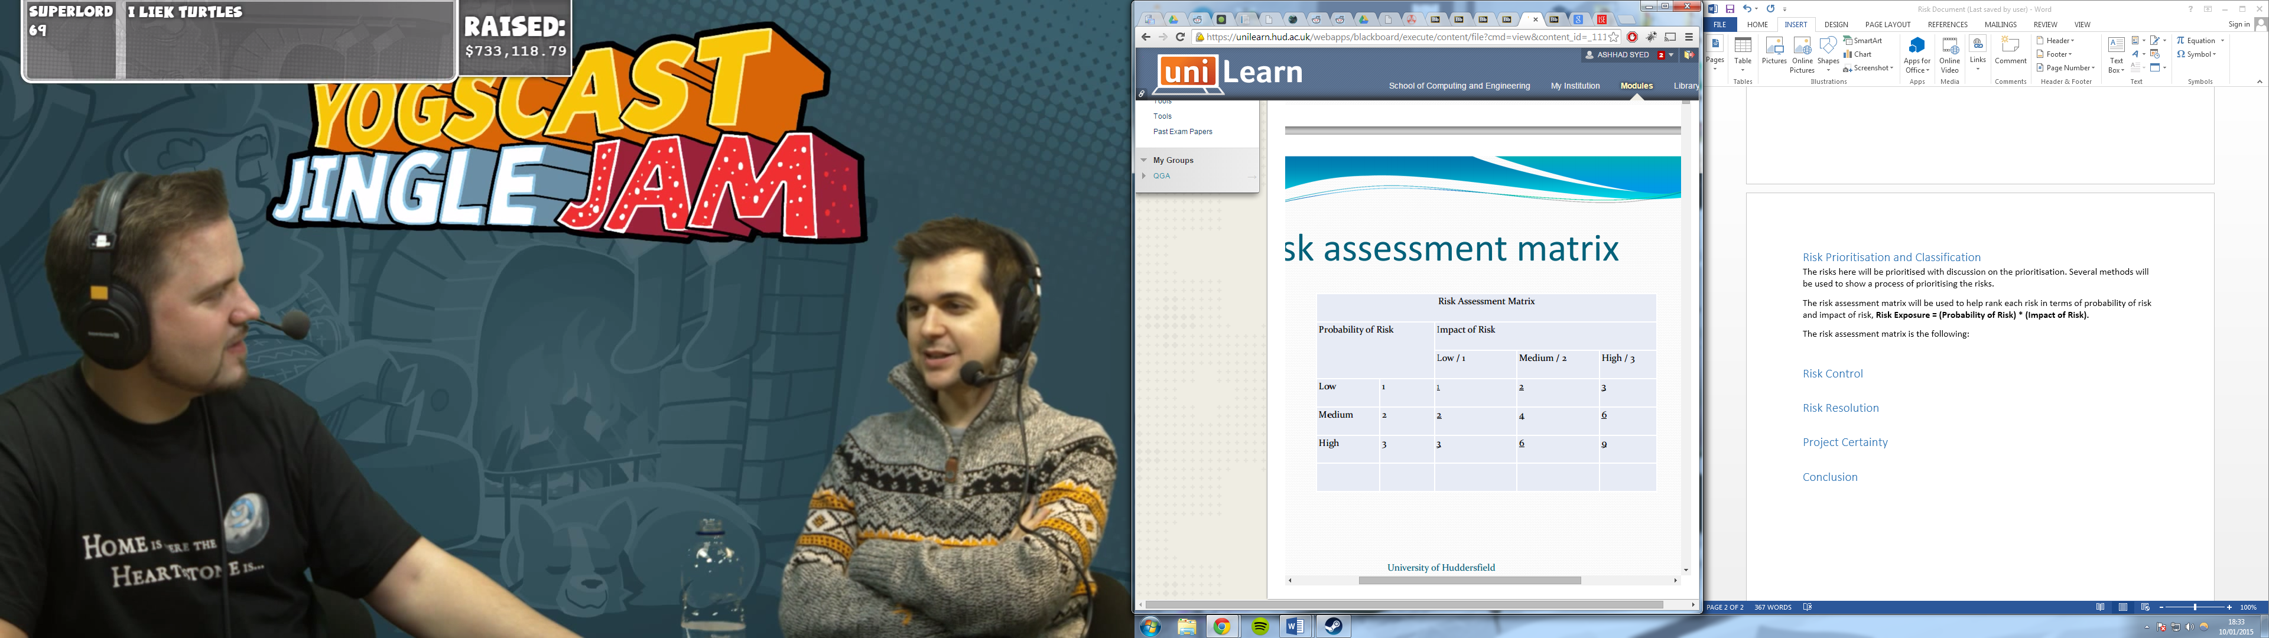

Figure 1 - Risk Assessment Matrix

The risks will now be assessed using the above matrix:

## Failing to extensively learn new platform

The probability of this risk happening is medium to high when it comes to implementation of the more complex features of the projects product. The impact of this on the completion of every milestone of the project is high.

Features may be lost as a result of this risk not being correctly accounted for.

**Risk Rating: 6**

## Only 2 members in the group

This risk means that there is less man hours to commit to the project than compared to bigger groups. As there are only 2 members in the group the impact of this risk on effecting project progress and the feasibility of attaining requirements is quite high. The impact of this is medium to high, this is because there are a limited number of hours available with a limited amount of manpower, and it may become an issue if one member neglects their workload. How to deal with this risk will be further discussed in the risk control section.

**Risk Rating: 6**

## Little feedback on qualitative studies

This chances of this risk happening are medium as there is not much previous knowledge on this. Some qualitative studies will be performed during analysis and design to get an idea of what requirements may have been missed. The impact of little feedback will be low as a lot of research and analysis has been done with the client and other research material.

**Risk Rating: 2**

## Conflicting Workloads

The probability of other workloads affecting the progress of the project is low to medium. This again will be discussed in more detail under the risk control section. The impact of this risk is medium as it may lead to significant delays in project completion.

**Risk Rating: 4**

## Illness, family matters and extenuating circumstances

The probability of this risk is low however the impact is at high. If this risk becomes reality we could face issues with the project completion. This will also be discussed in more detail under the risk control section.

**Risk Rating: 3**

# Risk Control and Resolution

In this section the response types along with how to deal and resolve each risk will be discussed.

There are six response types to a risk, these are:

* Avoidance
* Mitigation (also known as Risk Reduction)
* Acceptance (also known as Retention)
* Transfer
* Absorption or Pooling
* Knowledge and Research

Each risk in the project will be discussed and analysed to determine which response type is the most appropriate and how to resolve the impact or probability of each risk as required.

## Failing to extensively learn new platform

When developing the plugin for a new platform which each member of the group need to learn first, the risk of being unable to implement more complex features in the set time is quite high. The impact of it as well is dangerous to the completion of every “***must have***” requirement.

Mitigation will be the response as the plan for completing the requirements will need to be adjusted. If certain complex requirements take longer to complete then the plan must be changed, if deadlines won’t be met then perhaps the MOSCOW requirements list will need to be changed as well. Group meetings will need to be held and meetings with the client will need to be held. There the requirements to meet will be discussed and altered according to the severity of this risk.

## Only 2 members in the group

This risk is similar to the one above, as there are only 2 members in the group project, the amount of hours that can be dedicated to implement the product a much lower than average sized group projects. This could result in delaying of milestones and ultimately not accomplishing all the must have requirements.   
Mitigation will be the response as the plan for completing the requirements will need to be adjusted. If certain requirements take longer to complete than planned then the plan must be changed, if deadlines won’t be met then perhaps the MOSCOW requirements list will need to be changed as well. Group meetings will need to be held and meetings with the client will need to be held. There the requirements to meet will be discussed and altered according to the severity of this risk.

## Little feedback on qualitative studies

If this happens the impact of the risk is very low as lots of research has and will be conducted to mitigate the impact. A questionnaire will be designed and sent to year 2 students which will allow for any extra requirements to be identified. However if the response is low then the already identified requirements from the client and relevant research will be enough.

Acceptance will be the response to little feedback as there is nothing more that can be done for that one qualitative study. Perhaps if time allows it other questionnaires or surveys can be designed and sent out again, these may provide more substantial feedback.

## Conflicting Workloads

If other modules coursework / exams require more time than first expected then the group projects progress will be affected, especially more so as there are only 2 people in the group.

Mitigation will be the response as the plan for completing the requirements will need to be adjusted. This depends on how much the other modules workloads affect each member’s ability to work on the group project. As both members take the same modules the likely hood of both getting affected the same is high, therefore group meetings will help re-plan how to approach each requirement of the group project.

## Illness, family matters and extenuating circumstances

This risk is self-explained, as if one of the 2 members is ill or can’t dedicate time to the project due to any extenuating circumstances then the project progress will be greatly affected. As effectively if one member is unable to work, then half of the group will have to make up for this, which is one member in this case.  
Mitigation and or Acceptance will be the response type to this risk. If the time taken out by a member of the group is minimal then a new plan will be devised and potentially requirements will be reprioritised. However if the time taken out is substantial then acceptance will be the appropriate response, here a meeting will be held with the client were next steps will be discussed.

# Project Certainty

In this section the project certainties will be outlined and discussed, at the end a project certainty type will be chosen relevant to the group project. This will then lead onto the design aspect of the project where the methodology will be suggested.

There are three certainty types, these are:

* Product Certainty
* Process Certainty
* Resource Certainty

Product certainty is based on how clear and well specified the requirements are for the project.

Process certainty is based on the development process; this is influenced by the experience of both the development and managerial members involved and their experience of the tools and techniques available.

Resource certainty is based on the availability of staff (group members in this case), the research and knowledge on the area of research for the project, development resources and tools available.

The following image shows the different combinations of certainty.

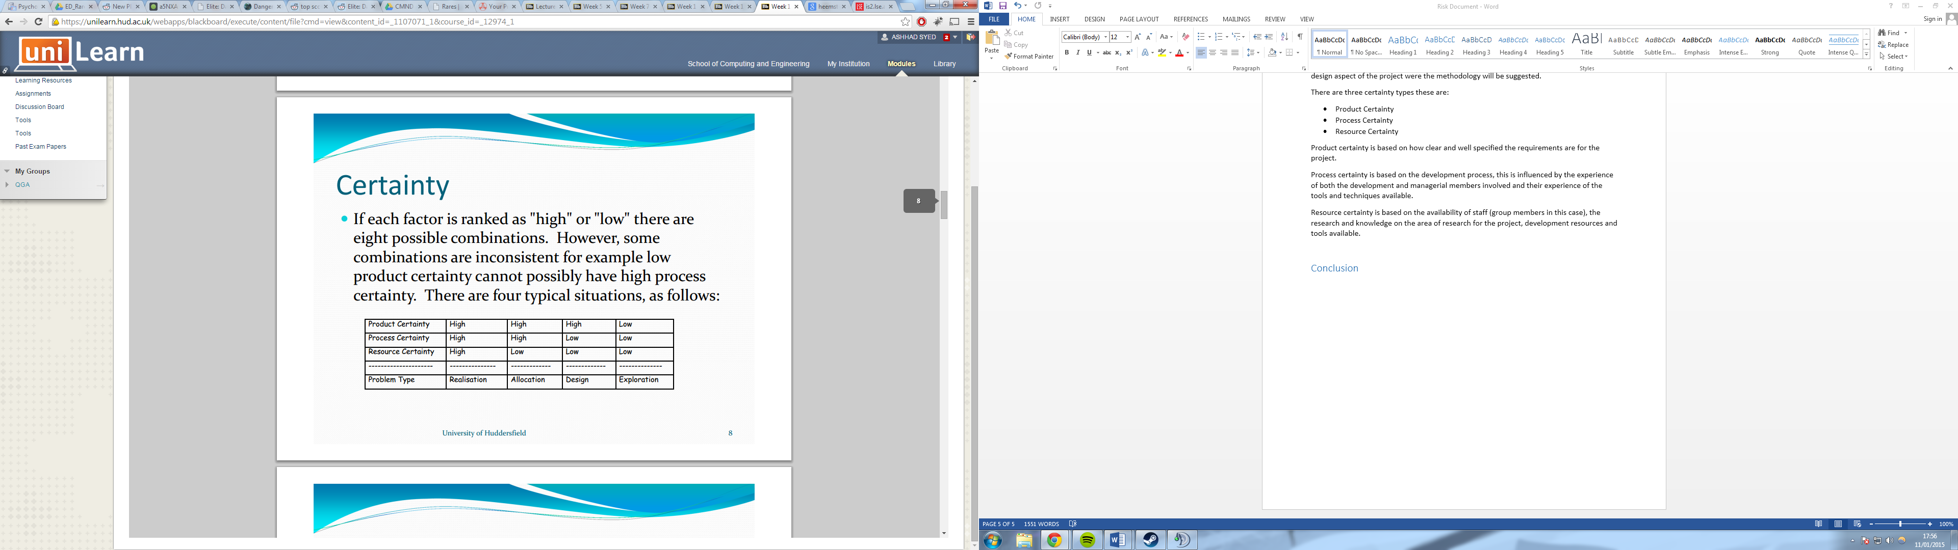

Figure 2 - Combinations of Certainty

The group project has high product certainty, low process certainty and low resource certainty.

Requirements are very clear and have been confirmed by the client.  
The experience of the members in the group of creating a plugin for eclipse before is low, which is the main development effort. Experience of managing a development project is medium to high.   
The resources available for creating the plugin are low to medium.

Therefore the project certainty problem type is Design.

This means an appropriate life cycle will need to be chosen to deal with this problem type.

As what is wanted is known but not how to build it, a prototype approach will need to be taken. As with this each prototype will accomplish a requirement with client feedback after each successful prototype. Extensive planning of milestones will be required as these will change as the project goes on due to the agile / prototype approach.

This will allow the group to tackle the design and implementation phase in each cycle and therefore slowly build the full project as process and resource certainty is slowly improved. Overtime the members will have more knowledge on how to build each part of the product to fulfil certain requirements.

The risk analysis therefore has helped make sure to point out how to tackle the project’s design and implementation phase and keep in mind what can go wrong.

# Conclusion

In conclusion, throughout the development of our projects we will have to be vigilant in risk management. It is important that before we start any of the key production and documentation we should fully evaluate all of our risks and produce a plan to deal with each risk.

In any project risk management is crucial, failure to consider risks could lead to an overall failure in the project. We should be wary of any changes that may impact our project and account for any risks that we can both control and that are beyond our reach.

Steps can be taken to mitigate and avoid risk and a strategy to deal with the effects of potential risks will need to be developed further.